# Iteration Four

## The goal

To implement a pause button

### Tasks

|  |  |  |
| --- | --- | --- |
| **Task** | **Time Estimate** | **Actual Time Taken** |
| Analysis and Planning | 90 min | 90 min |
| Coding | 30 min | 30 min |
| Testing | 30 min | 30 min |

### Analysis and Planning

In the last iteration I added the Game class to keep track of variables throughout the game. In this iteration I plan to add a boolean attribute to indicate whether the game is paused or not. I will call it Game.paused.

This flag will be set upon loading a level and when the pause key is pressed (on the keyboard). It will be unset when any action key is pressed.

The flag will be checked before updating the position of any actors and before cycling the timer, resulting in a stationary display and a paused timer. A message will be printed on the screen stating that the game is paused.

### Class Diagram Before:



### Class Diagram After:



### Design

## Activity Diagram



## Planning a Complex Algorithm

Define the problem

*Need to show a pause screen*

Inputs to the routine

*Game data object*

Outputs from the routine

*None*

Pre-conditions

Current game display is rendered to the canvas

Post-conditions

*Pause screen is rendered over the game display*

Name the Routine

*pauseMenu()*

Think about error handling

*none*

### Pseudocode

CanvasDisplay.pauseMenu () {

Define text  
 find centred position  
 choose colour  
 dim background  
 draw text

}

### Evaluation

I spent some time during this iteration deliberating over when to check whether the game is paused, what to write on the screen when it is and whether to start each level paused or not. After a while I spoke to some classmates to get their opinions and decided to go with their suggestions. I believe it is important to think about the end user when building any system, and this exercise was a great opportunity to do just that.

I ran the code through standardJS which complained about two minor style defects which were quickly fixed.

### standardJS Before

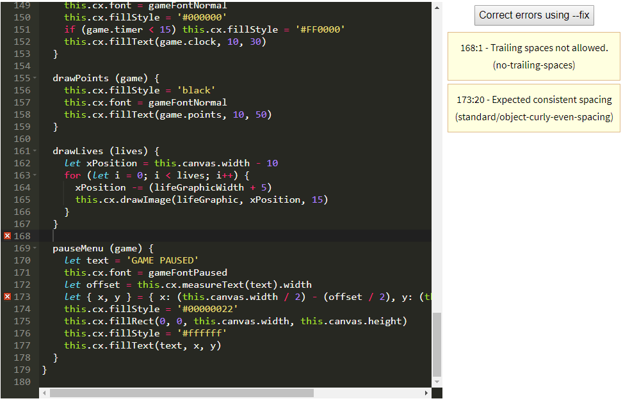

### standardJS After

